

**2025 REGISTRATION GUIDE**

Carlingford Netball Club warmly welcomes all new, transferring and returning players to the 2024 Winter Netball Season. Players are required to register through **PlayHQ**.

**AGE GROUPS & REGISTRATION TYPES**

Carlingford Netball Club accepts registrations from 5 years of age through to Seniors. A player’s age at 31st December 2024 determines their eligible age group.

|  |  |  |  |
| --- | --- | --- | --- |
| Type | Description | Age Group | Birth Year |
| NetSetGO – Net | Carlingford Netball Club **Beginners Squad**  8 Week Introductory Netball Basics Program held in Terms 1 & 4 on Wednesday Evenings at Don Moore Reserve - (February 12 – April 2) and (October 22 – December 3) | 5 to 10 years | 2015-2020 |
| NetSetGO -Set & GO MODIFIED COMPETITION | **Set & GO** - Under 8’s & Under 9’s Modified Competition matches versus other Hills District Netball Association (HDNA) clubs on Friday Nights at Pennant Hills plus training one night per week at Don Moore Reserve. | 6 to 9 years | 2016-2019 |
| Winter Junior COMPETITION | Under 10’s to Under 15’s Competition matches versus other HDNA clubs played on Saturday mornings at Pennant Hills plus training one night per week at Don Moore Reserve. | 10 to 15 years | 2010-2015 |
| Winter Senior COMPETITION | **Cadets** - 16 to 19 Years Competition matches versus other HDNA clubs played on Saturday afternoons at Pennant Hills plus training one night per week at Don Moore Reserve.  **Seniors** – 19 Years and over Competition matches versus other HDNA clubs played on Saturday afternoons at Pennant Hills plus training one night per week at Don Moore Reserve.  **Winter Junior** players are permitted to register for both a Junior and Senior team (Cadets or Seniors). | 16 years and over | 2009 or earlier |
| Non-Playing | Coach, Team Manager, Official (Umpire) or Volunteer | 12 Years and over |  |

**REGISTRATION** **FEES**

Carlingford Netball Club sets an annual fee, incorporating onward annual charges set by and payable to Netball Australia, Netball NSW and the Hills District Netball Association (HDNA).

We offer an **Early Bird discount** of $40 for Set & GO Modified Competition, Winter Junior and Winter Senior (incl Cadets) registrations through to **Sunday January 19.** Full fees will be charged from **Monday January 20**.

Payment can be made by Visa or Mastercard at the time of registration. Please note there is a credit card surchargeapplied to all registrations by the card provider.

Carlingford Netball Club is a registered **Active Kids Voucher** provider. Please visit Service NSW to download the voucher prior to registering. [**The Active Kids Voucher Program**](https://www.service.nsw.gov.au/transaction/apply-active-kids-voucher) provides a $50 discount for all eligible NSW children attending school, aged 5 to 18 years.

**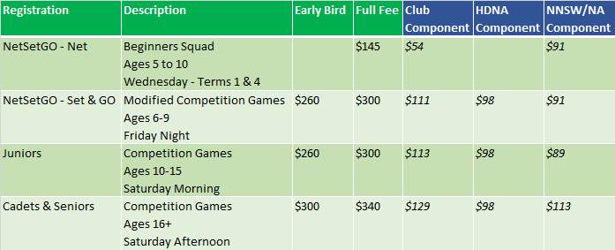  
\*** All fees exclude a credit card provider surcharge

**HOW TO REGISTER**

* Step 1 - Click the Register Here link on the Carlingford Netball Club website, Facebook Page or email.
* Step 2 – Select the Competition – Hills District Netball Association, then:
  + **Suncorp NetSetGO – NET** (Beginners Squad);
  + **Suncorp NetSetGO – Set & GO MODIFIED COMPETITION** (Ages 6-9);
  + **Winter Junior (Under 10-15)**; or
  + **Winter Senior (Cadets & Seniors)**
* Step 3 – Click **Create an account** (register your details, even if registering for your child – for first time)
* Step 4 – Enter your first name, last name, email address, mobile number, set a password and click **Sign up** (password must contain at least 1 uppercase letter, at least 1 number, at least 1 special character and be at least 8 characters)
* Step 5 – Enter the verification code sent to your added email address and click **Confirm code**
* Step 6 – Once your account has been verified, please log in to your PlayHQ account with your added email and password
* Step 7 – Choose User – click one of the following
  + **I am registering myself;** or
  + **I am registering someone else** and click **Continue**
* Step 8 – Choose Role – click one of the following
  + **Player;**
  + **Coach;**
  + **Team Manager;**
  + **Official; or**
  + **Volunteer** and click **Continue**
* Step 9 – Complete **Participant** details, including **Additional** Details and **Emergency** Contacts. Click Save and Continue
* Step 10 – Tick – **I have read and agree to the terms of…** and select **Continue**
* Step 11 **–** Select Uniform/Club Merchandise Products to purchase (should you require)
* Step 12 – Check Final Payment & Summary – **Select NSW Active Kids Voucher** from **Government Vouchers** drop down menu and enter voucher number (should you wish to use this voucher)
* Step 13 – Complete Registration with **Credit Card payment**

**ADDITIONAL REGISTRATION INFORMATION**  
  
**Proof of Age:** New players may be requested to supply Carlingford Netball Club with a certified copy of their Birth Certificate or Passport as part of the Registration process.  
  
**Refund Policy:** If a registered player cannot be placed into a team, a full refund of registration fees will be given.  However, if a player is allocated to a team, a refund will only be provided in exceptional circumstances (e.g. Doctors certificate, out of area move). Please note that this will be at the discretion of the Club Committee and a $20 administration fee may also apply.

**NEEDING HELP TO REGISTER OR ANY FURTHER INFORMATION?**

Please contact our Registrar, Belinda Turco at [carlonetball@gmail.com](mailto:carlonetball@gmail.com) or 0405 453 578.